**WhatsApp**

**User Guide**

**Table of Content**

1.0 Introduction 3

2.0 Purpose 3

3.0 Common Terms or Acronyms 3

4.0 Download and Installation 3

5.0 Chat 5

6.0 Desktop calling 6

6.1 Voice Call 7

6.2 Video call 7

1.0 Introduction

WhatsApp is an internationally available freeware, cross-platform, centralized instant messaging, and voice-over-IP service owned by the American company Meta Platforms. It allows users to send text and voice messages, make voice and video calls, and share images, documents, user locations, and other content.

2.0 Purpose

The purpose of this document is to provide detailed information about the WhatsApp desktop application.

3.0 Common Terms or Acronyms

|  |  |
| --- | --- |
| **Abbreviation** | **Expanded Form** |
| mac | Macintosh |
| IP | Internet protocol |

4.0 Download and Installation

Refer following steps to download the WhatsApp software desktop version.

1. Open internet browser.
2. Go to link <https://www.whatsapp.com/download/>

Click on download icon for windows option.

1. Microsoft Store window opens. Click on Install button.

1. Click on open

1. Click on Get Started button.

1. Follow the below listed steps to complete installation.

1. WhatsApp is successfully installed. To open WhatsApp, go to programs and select WhatsApp icon.

5.0 Chat

Chat feature enables user to chat with their saved contacts.

1. To start a new chat or start a new group, click on New Chat icon.

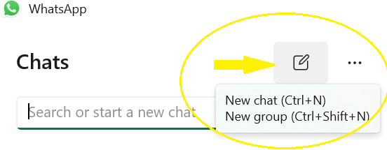

1. Click on New chat button.
2. Click on the contact you want to chat. Chat window opens.
3. Type your message as shown by yellow arrow in the picture below.
4. To record a voice message, click microphone and start speaking. Once finished, click check mark.
5. Click play to listen to the messages you have sent or received.
6. Voice messages you received are downloaded automatically. Green microphone for the messages you haven’t played and blue microphone on the messages you have already played.

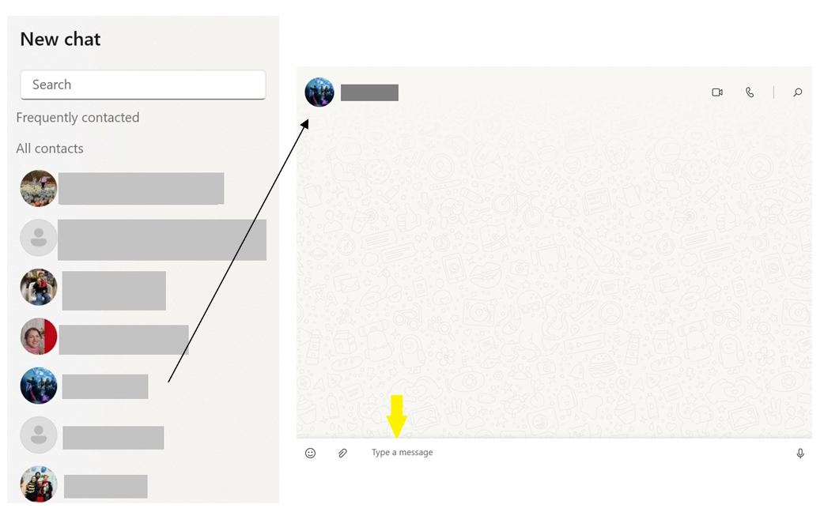

1. 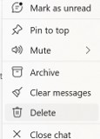To archive a person, right click on contact name and click archive. You will still receive messages from the contacts that are archived. These chats stay archived when new messages are received.

6.0 Desktop calling

To make or receive voice calls on WhatsApp Desktop:

* You’ll need an active internet connection on your computer and phone.
* WhatsApp needs access to your computer’s microphone.
* You’ll need to have an audio output device and microphone connected to your computer for calls.

**Note**: Use a headset for the best audio. Using a separate external microphone and speaker devices might cause echo.

6.1 Voice Call

Make a voice call select the button as shown by yellow arrow.

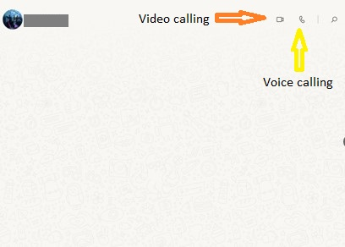

During the call, you can mute or unmute your microphone by clicking the Microphone icon. To end a call, click **End call**.

**Answer a voice call**

If you receive an incoming call, you can click:

* **Accept** to accept the call.
* **Decline** to decline the call.

6.2 Video call

Video calling lets you call your contacts using WhatsApp Desktop for free, even if they’re in another country. Video calling uses your internet connection. Desktop calling is supported on Windows 10 64-bit version 1903 and newer, macOS 10.13 and newer. Group calls aren’t supported on WhatsApp Desktop at this time.

**Make a video call**

1. Open the individual chat with the contact you’d like to call.
2. Click the **Video call** icon.

During the call, you can mute or unmute your microphone by clicking the Microphone icon or turn your camera off or on by clicking the **Camera** icon. To end a call, click **End call**.

**Answer a video call**

If you receive an incoming call, you can click:

* **Accept** to accept the call.
* **Decline** to decline the call.